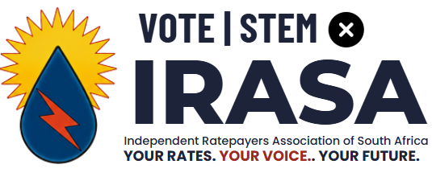
- Candidate: Frans Roos
- Party: IRASA (Independent Ratepayers Association of South Africa)
- Election: Local Municipal Elections 2026 – Matlosana Local Municipality
- Contact: 083 378 8826
- Website: www.votefransroos.co.za
- Youtube: https://www.youtube.com/results?search_query=irasa
- Facebook:
- Irasa’s Website: www. https://irasa.org.za/
- Candidate’s Website: www.fransroos.co.za

1. IRASA’s core beliefs for 2026: independent, community-first councillors
The Independent Ratepayers Association of South Africa (IRASA) is contesting the 2026 Municipal Local Elections on a simple idea: local councillors must work for residents, not for political parties. Founded in 2005 as a registered national party, IRASA’s mission is to shield councillors from party interference, so they are directly accountable to the communities that elected them.

Core beliefs of the IRASA platform
IRASA’s platform is built on direct democracy at local level. It treats councillors as employees of the voters, funded by residents’ rates and taxes, and judged on service delivery, not party loyalty. Its candidates commit to:
- Holding regular public consultations and ward meetings
- Listening to community concerns before taking positions in council
- Voting in the best interests of residents, even when it goes against a party whip or coalition deal
In practice, this means IRASA independents focus on basics like water, electricity, roads, refuse removal, and transparent budgeting, rather than national political agendas.

2. Why independent representation is critical now
South Africa’s municipal landscape has changed. More councils are “hung”, with no single party holding a majority, and coalition governments are now common. In this environment, party-dominated decision-making often leads to instability, backroom deals, and service delivery taking a back seat to political survival.
Independent representation through IRASA is critical because:
- It breaks the automatic “party-line” voting that can ignore local needs
- It gives residents a direct channel to influence how their rates and taxes are spent
- It adds a stabilising, community-focused voice in coalition negotiations, pushing parties to prioritise services over power-sharing
- It shows voters that there is a credible alternative to the usual party-dominated system, as IRASA has already won seats in multiple municipalities since 2005, including in the 2016 and 2021 elections.
In short, IRASA’s 2026 campaign argues that strong, independent, ratepayer-backed councillors are essential to restore accountability, improve basic services, and make municipal government work for ordinary people again.

3.Who is Frans Roos
Candidate for IRASA (Independent Ratepayers Association)
Local Municipal Elections 2026 – City of Matlosana
PROFESSIONAL PROFILE Dedicated Master Practitioner in Real Estate, entrepreneur, and community leader with over 35 years of hands-on experience serving the Matlosana region. A firm believer that municipal governance must first and foremost be accountable to ratepaying residents. Brings deep expertise in property markets, municipal financial policy analysis, infrastructure oversight, and civic action to advocate for transparent, value-driven local government.
KEY COMPETENCIES & EXPERTISE
- Municipal Financial Oversight: Independent analysis of Integrated Development Plans (IDP), MTREF budgets, capital expenditure, property valuations, and Auditor-General reports.
- Real Estate & Local Economy: Understanding the direct link between effective municipal service delivery, property values, and sustainable economic growth.
- Civic Action & Urban Renewal: Mobilizing community partnerships to repair and restore local public spaces (e.g., #OnsDorp and Doringkruin neighborhood initiatives).
- Public Participation & Advocacy: Formulating formal written and oral policy submissions to protect taxpayers' rights and ensure responsible spending.
LOCAL GOVERNMENT & CIVIC INVOLVEMENT
- Policy & Budget Analysis:
  - Rigorously evaluates City of Matlosana operational and capital budgets to determine the tangible value generated for every rand spent.
  - Focuses on tariff hikes, debt collection practices, financial sustainability, and structural infrastructure maintenance.
  - Submits formal comments and objections against non-value-adding policies, inefficient spending, and flawed property valuation rolls.
- Community Leadership & Urban Renewal:
  - Championed citizen-led renewal models combining residents, local businesses, and civic organizations to restore degraded municipal infrastructure.
  - Spearheaded neighborhood restoration drives through initiatives like #OnsDorp, restoring pride and safety to local communities.
IRASA CANDIDATE PLEDGE & VISION As an independent representative under the Independent Ratepayers Association (IRASA), I commit to providing constructive opposition and strict oversight in the municipal council:
- Protect Ratepayer Rights: Ensure municipal funds are spent with strict financial discipline and total transparency.
- Prioritize Essential Services: Hold council accountable for maintaining water, electricity, sanitation, roads, and waste collection.
- Evaluate Proposals on Merit: Assess all municipal proposals independently rather than following partisan political agendas.
- Empower Citizens: Strengthen public participation mechanisms so resident voices directly influence municipal decision-making.
CAREER HISTORY
- Master Practitioner in Real Estate & Entrepreneur | 35+ Years Experience
  - Managing property portfolios, advising clients on real estate investments, and analyzing the impact of local government performance on property values and local commerce.
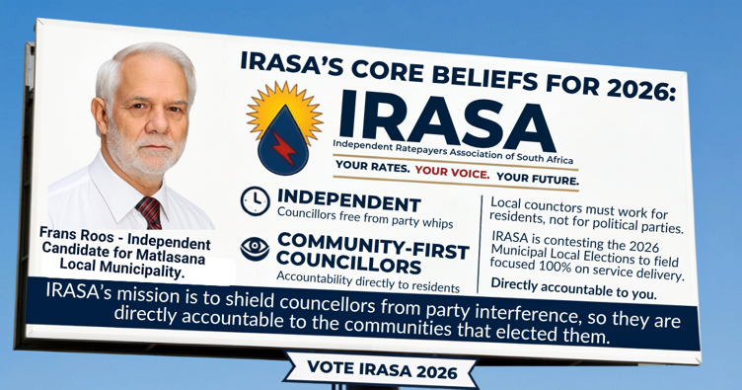

4. Candidate’s Pledge – Frans Roos
Independent Candidate for Matlosana Local Municipality (2026)
Backed by IRASA – The Independent Ratepayers Association of South Africa
I, Frans Roos, standing as an independent candidate for the Matlosana Local Municipality, hereby make this pledge to all residents, ratepayers, property owners, and businesses in our area. My mandate comes from you, not from a political party. If elected, I will serve as your direct representative in council, with a clear focus on policy review, genuine public participation, and strong oversight.

4.1. Policy review: fair, transparent, and affordable rules for all
I will actively review and challenge municipal policies, by-laws, and tariffs that affect your daily life and costs. My focus will include:
- Property rates, service charges, penalty fees, and interest on arrears
- Water and electricity tariffs, connection fees, deposits, and disconnection policies
- Land use, zoning, subdivision, and building plan approval processes
- Local business licensing, trading by-laws, informal trading rules, and compliance requirements
I will work to ensure that all policies are:
- Clear, accessible, and written in plain language
- Fairly applied across residential, commercial, and industrial categories
- Linked to actual service levels – residents and businesses should not pay full rates for services that are unreliable or not delivered
Where policies are outdated, inconsistent, or financially burdensome without justification, I will:
- Request detailed explanations from municipal officials
- Table formal motions for policy review and public comment
- Insist that major changes be exposed to proper public participation before council approval

4.2. Public participation: your voice before and after elections
Public participation must be real, not a formality. I pledge to:
- Publish advance notice of key council discussions on budgets, rates, tariffs, and land-use changes, with simple summaries of what is proposed and why
- Host structured input sessions in different parts of Matlosana before major votes
- Accept and record written submissions from individuals, bodies corporate, business forums, and community organisations
- Report back after council meetings on:
  - What issues were raised by the public
  - How those inputs were considered in council
  - Why certain decisions were taken, even when they go against public input
You will not have to wait five years to hold me accountable. My mandate depends on ongoing consultation, not just a ballot on election day.

4.3. A strong voice for property owners and businesses
Property owners and local businesses carry a significant portion of the municipality’s revenue burden. I will ensure their perspectives are heard and respected in council. To this end, I commit to:
- Establishing a regular Property Owners and Business Forum, open to:
  - Residential owners and landlords
  - Commercial and industrial property owners
  - Local enterprises, from small shops to larger firms
- Using this forum to gather structured input on:
  - Rates and tariff policies
  - Service delivery priorities (water, electricity, refuse, roads)
  - Security, trading environments, and infrastructure needs
  - The impact of municipal decisions on property values and business viability
- Presenting consolidated positions from these forums in council, so that decisions reflect real economic and community realities on the ground
- Pushing for predictable, consultative processes before any major increases in rates, tariffs, or new fees that directly affect property and business costs
This is not about favouring one group over another. It is about ensuring that those who fund much of the municipality’s budget have a meaningful say in how it is run.

4.4. Building lasting community forums
Beyond property and business, I will help build broader, inclusive community forums that:
- Meet regularly in different neighbourhoods and business nodes across Matlosana
- Include residents, ratepayers, small businesses, community organisations, churches, schools, and local institutions
- Focus on local priorities such as:
  - Reliable basic services (water, electricity, refuse, roads, stormwater)
  - Safety and security in residential and business areas
  - Local economic activity and job creation
  - Maintenance of public infrastructure and spaces
- Feed structured, documented input into ward-level and council-level agendas
These forums will be the backbone of ongoing public participation, ensuring that council decisions are informed by people who live, own, and work in Matlosana every day.

4.5. Oversight and accountability: no blank cheques
In a context of hung councils and coalition politics, oversight is critical. I pledge to:
- Vote in council based on what is best for Matlosana residents, not on party instructions or coalition deals
- Demand clear, measurable performance targets for municipal officials and service providers
- Support audits, investigations, and consequences where money is wasted, services fail, or procurement processes are irregular
- Push for regular public reports on:
  - Water losses and electricity outages
  - Infrastructure projects and their status
  - Procurement contracts and service provider performance
  - Arrears management and debt collection practices
Where necessary, I will use my position to call for:
- Special council meetings on urgent local issues
- Formal questions to the mayor, portfolio heads, and municipal manager
- Access to information that affects your community, in line with the law

4.6. Independent, but not isolated
As an IRASA-backed independent, I will work with any party or group that supports better services, sound financial management, and genuine accountability. However, I will not be bound by party whips, secret coalition agreements, or instructions that conflict with the interests of Matlosana’s residents and ratepayers.
My loyalty is to you – the people who live here, own property here, run businesses here, and pay the rates and taxes that keep this municipality running.

Signed:
Frans Roos
Independent Candidate – Matlosana Local Municipality
Backed by IRASA – The Independent Ratepayers Association of South Africa

